Quest Journals
Journal of Software Engineering and Simulation Volume 9 ~ Issue 4 (2023) pp: 53-61
ISSN(Online) :2321-3795 ISSN (Print):2321-3809



Research Paper
Student Result Management System
Rainy
Department of CSE
Chandigarh University
Mohali, India
Dipti Sharma
Department of CSE
Chandigarh University
Mohali, India
Harmanjeet Singh
Department of CSE
Chandigarh University
Mohali, India
Abstract—An online platform called a Student Result Management System was created to make it easier to manage student scholastic records, grades, and other related data. For students, teachers, and administrators to view and handle academic records, the system offers a user-friendly interface. While students can view their grades, attendance, and other academic information, teachers can input and update student grades, data, and other pertinent information. Additionally, the system offers real-time analytics and reports to assist administrators in making fact-based choices. In handling student academic records, a Student Result Management System should be accurate, effective, and transparent. This abstract emphasizes these features and advantages. The system is intended to automate and simplify the process of managing student data, including keeping track of grades, attendance, and other data, producing reports, and giving students and parents academic input. The whole world and the administrators of educational institutions in our country care about the accuracy of student results. The overall academic performance of the student is affected by the presence of the student in his institute. Mainly there are two common methods of taking the results and presenting them on the result sheet or recording the student's mark on paper. Both were more time consuming and inefficient. Therefore, a computerized student performance management system is necessary to help the faculty maintain attendance records. The article examines various computer output management systems. This article identifies a key issue in student attendance management that has traditionally been addressed by faculty. Computer View offers one way to automate the student scoring system. This article examines the various computer systems that have been developed using various techniques Based on this review, a new approach to recording and managing student participation is proposed for various colleges or academic institutes.
The Student Performance Management System is a computer platform that simplifies the process of recording, storing and retrieving academic information and student records. This system helps educational institutions manage student data efficiently and minimize errors and redundancy. The system facilitates the automation of tasks such as scoring, reporting and transcript generation, which improves the accuracy and speed of processing results.
The system is designed to store student records, including personal information, academic records and other relevant information. It allows students and teachers to access these records online, allowing easy retrieval of student records and results. In addition, the system provides a variety of features to track student performance and academic progress, including grade reporting, course scheduling, and attendance tracking.
A student performance management system offers several benefits to educational institutions, such as administrative efficiency, student performance tracking and better decision making. This helps streamline the processing of results, which reduces staff workload and ensures accurate and timely delivery of results. Overall, a student performance management system is an important tool for educational institutions that want to optimize their academic processes and improve student outcomes.
*Corresponding Author: Rainy 53 | Page

Student Result Management System
Received 02 Apr., 2023; Revised 13 Apr., 2023; Accepted 15 Apr., 2023 © The author(s) 2023. Published with open access at www.questjournals.org
I.INTRODUCTION
A student performance management system is a computer application that helps educational institutions manage, record and analyze student academic records, including grades, attendance and other relevant information. The system streamlines the management of student records by making it easy for administrators, teachers and parents to access and analyze student performance data.
A typical student performance management system has the following characteristics:
Student Profile Management: This feature allows administrators to create, store, and update student information, including personal information, academic records, attendance information, and test scores.
Grade Management: This feature allows teachers to enter test scores and generate grade reports for individual students or classes.
Reporting: The system can generate various reports including exam result reports, attendance reports and student performance reports. Analysis: The system can analyze student performance data and generate useful insights for teachers, administrators and parents.
Communication: The system can facilitate communication between teachers, administrators and parents, for example through automatic email notifications and alerts. Overall, a student performance management system helps educational institutions manage student records more efficiently, resulting in better academic performance and better decision-making.
As the number of people living on earth increases steadily, their need for more resources grows as well. In order to use the living spaces better, water, food, and energy supplies need to be used more efficiently by the communities. Indeed, this “need perception” has enabled people to create new technologies and useful inventions starting from the Industrial Revolution to World Wars. Production alone is not sufficient to sustain daily life. Communication of information and transportation of goods are also essential.
In a typical student performance management system, student data is entered into the system by teachers and administrators, and the system automatically generates reports based on the entered information. Reports may include test scores, attendance information, and student performance reports.
The system also provides tools to analyze student performance data and generate insights that help teachers make better decisions about student support. For example, the system can identify trends in student performance, such as subjects students struggle with, and make recommendations on how teachers can adjust their teaching methods to better support students. To achieve a high-level position and a higher salary than expected advanced education is necessary for every organization. A lot studies were conducted to analyze the factors refers to the academic performance of students in various fields universities, but less is done for private universities. price education in private universities is much higher in comparison those of public institutions. There are no guarantees the right to enter any college leads to success degree course. But academic success can be there are several factors that can lead to success anywhere student life To improve quality universities, private universities and colleges must maintain a review and evaluate the excellence of the curriculum components, study and academic programs, research and scholarship, staff, students, physical facilities, equipment and learning materials and academic environment” [14]. Access to factors of academic performance is also important to help students develop personal academic success at university. This the purpose of the study is to focus on interaction various factors and their role in performance college or university researchers.
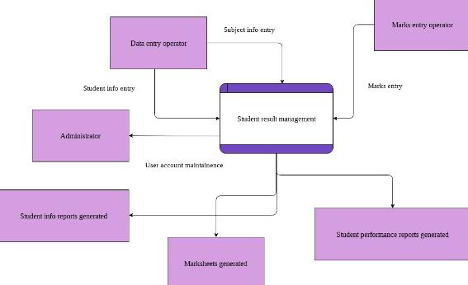
*Corresponding Author: Rainy 54 | Page

Student Result Management System
1.1 | Data flow diagram of Student Result Management System
The purpose of this study is to identify and investigate most likely factors affecting academic performance student activity in colleges Delhi, India. A study was conducted to identify this various factors that affect student performance university degree and then we established the relationship between these factors and their effects of the student's result. We also analyzed the performance of students based on gender and could get good analysis results. This paper is based on of a study conducted to analyze academic success students in a higher education setting. Sample group students are admitted to MCA course which is M.Sc degree program in computer science. We adopted various statistical tools for the study. The analysis of the academic performance of students is a major concern for universities and colleges. it is important from the point of view of planning and managing studies pedagogy Analyzing student performance is essential to understanding how effective is the current education system. The data separation is done using the clustering method. K-means clustering algorithm is implemented in R [15][16]. We used Microsoft Excel to analyze and describe the data different letters. Various methods such as clustering algorithms can be useful in performing analysis, for example student performance to assess the impact of various factors performance [1]. The ultimate goal of research is to formulate teaching pedagogy based on data analysis. The factors affecting the academic performance of students each cluster helps identify strengths and weaknesses current pedagogical teaching. The final result of the study is effective teaching pedagogy that can handle anything factors.
II.EASE OF USE
The want for a scholar end result control gadget arises from the truth that academic establishments should manipulate massive quantities of scholar facts, inclusive of educational records, attendance, and different applicable information. Managing this facts manually may be time-ingesting and error-prone, and might result in inconsistencies and inaccuracies in scholar records.
A scholar end result control gadget can assist cope with those demanding situations via way of means of offering a centralized platform for handling and reading scholar facts. Here are a few particular desires that a scholar end result control gadget can cope with:
Efficient record-keeping: A scholar end result control gadget affords a centralized platform for storing and handling scholar records, making it less complicated to get right of entry to and replace scholar facts.
Improved accuracy: By automating the technique of facts access and record-keeping, a scholar end result control gadget can assist enhance the accuracy and consistency of scholar records.
Streamlined reporting: A scholar end result control gadget can generate reviews automatically, making it less complicated for educators to investigate scholar facts and become aware of tendencies in scholar performance. Enhanced conversation: A scholar end result control gadget can facilitate conversation among teachers, administrators, and parents, offering a extra obvious and collaborative studying environment.
Better decision-making: By offering educators with get right of entry to to real-time facts on scholar performance, a scholar end result control gadget can assist them make higher choices approximately the way to guide
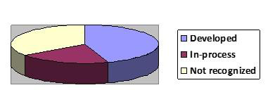
1.2 Statistics of Student Result Management System around the world.
III.LITERATURE REVIEW
Student performance management systems have been widely studied in the scientific literature, and many researchers have focused on the benefits, challenges, and implementation of these systems. In this literature review, I summarize some of the main findings of the relevant studies.
1. A study by Nithya and Uman (2018) investigated the effectiveness of a student performance management system in a higher education institution in India. The study revealed that the system made data management more efficient and helped eliminate errors and delays in processing results. In addition, the system enabled better communication between teachers, students and parents, which led to better academic results.
*Corresponding Author: Rainy 55 | Page

Student Result Management System
2. | Another study by Fajar et al. (2020) investigated the implementation of a student performance
management system in a private high school in Indonesia. The study found that the system helped streamline administrative processes such as grading and attendance tracking and improved the accuracy and timeliness of student performance reporting. The system also allowed for better communication between teachers, students and parents, resulting in more effective academic feedback.
3. In a study by Ayinde and Popoola (2016), the authors investigated the challenges of implementing a student performance management system in a Nigerian university. The study found that challenges such as lack of technical expertise, inadequate infrastructure and staff and student resistance to change hindered successful implementation. However, the authors suggested that these challenges can be overcome with proper planning, training and stakeholder engagement.
4. Finally, Kadir et al. (2020) investigated the potential of a student performance management system to improve student learning outcomes in Malaysian universities. The study found that the system helped identify areas where students needed additional support and enabled more effective tracking of student progress over time. The authors suggested that the system could be used to teach pedagogical practices and improve student engagement and motivation.
5. Learning always leads to performance. It is the main pointer to show learning is resulted. [5] explains about various categories of the outcomes of learning. They are defined as verbal information, intellectual skills, attitudes and motor skills. Learning process has an impact and importance for these outcomes. Various learning errands are required to show various learning results.
6. Grade Point Average (GPA) is a main measure for finding students’ performance academically [6]. It includes all the learning results anticipated of a student in his/her semesters’ subjects.
7. According to [7], an important interpreter of any students’ graduate performance is GPA. Thus, it can be considered as the main measure of student’s current and future studies.
8. As per [8], putting higher demands on student learner is more important as compared to external forces. 9. According to [9], the institutional guidelines and rules must be implemented properly to enhance the studying environment. It is needed that institution’s plans and procedures must be directed towards students’ accountability and they must be active enough to participate in their own college and university for promotion. 10. [10] did not consider other variables like students’ internal nature which would be obtained from students’ assessments or results
11. [11] studied both the students’ characteristics and self-reported theories to identify the aspects that add to the academic presentation of students at the university. Self-efficacy, assigned goals, self-goals and abilities are four major causes the students’ academic performances.
12. According to [12], students’ age is important for qualification which is essential for academic performance.
13. [13] through path analysis observed and explained gender to have a direct effect on the academic performance of third year students.
There are many academic institutions in India. But only a few institutions are modernized and use software to manage their daily work. A city like Bengaluru has around 1000 schools, more than 300 pre-university colleges and colleges. Most of these academic institutions still use the traditional way of administration, which mainly involves paper work and a lot of human effort.
Students admitted to educational institutions dependent on the traditional way of management have to work hard to obtain a certificate or other documents. Administrations also struggle to keep all the records, records, and retrieve records of interest to them in a timely manner. The managements of these institutions also have to hire several employees just to keep the accounting documents necessary to manage and support their daily work. Some universities like PESIT and Christ University in Bengaluru have their own online application which addresses the issues mentioned earlier.
Comparative Analysis
Table 1 summarizes the research into several student analysis approaches presented by various researchers.
*Corresponding Author: Rainy 56 | Page

Student Result Management System Table1. Comparative Analysis of already existing student result management system.
Author | Method used | Data set | Accuracy | Remarks
Robbins, S.B.,  Allen, J., Casillus (2006) | MySQLDatabase  Management System support | Student Dataset | NA | They investigated the effectiveness of a student performance management system in a higher education institution in India. The study revealed that the system made data management more efficient and helped  eliminate errors and delays in processing results.
S. R.  Brarmagoudar,R. P.  Geeta(2013) | Automated Students Result Management System using Oracle’s Database | 5286 Students Dataset | 85 | The study found that the system helped streamline administrative processes such as grading and attendance tracking and  improved the accuracy and timeliness of student performance reporting. The system also allowed for better communication  between teachers, students and parents, resulting in more effective academic  feedback.
Pooja Thakkar, Anil Mehta(2015) | Javascript for front end and PHP for Back end | Student Dataset | 89 | The study found that challenges such as lack of technical expertise, inadequate  infrastructure and staff and student  resistance to change hindered successful implementation
Bijoi C, Sanjay K., Bhibak S.(2016) | HTML,CSS,JAVASCRIPT, ReactJS | Undergraduate student dataset | NA | The study found that the system helped  identify areas where students needed  additional support and enabled more  effective tracking of student progress over time. The authors suggested that the system could be used to teach pedagogical practices and improve student engagement and  motivation.
Prof.Nithya and Uman (2018) | Angular and Bootstrap | Student Dataset | 91.2 | They are defined as verbal information,  intellectual skills, attitudes and motor skills.  Learning process has an impact and  importance for these outcomes. Various learning errands are required to show various learning results.
Niranjan  Lal,Navneet Kaur(2018) | Bootstrap ,NodeJS,ReactJS | 5,426 students | 92 | It includes all the learning results  anticipated of a student in his/her semesters’ subjects.
A Peda Gopi(2020) | HTML,CSS,JAVASCRIPT, JAVA | Student Dataset | 93 | Is an important interpreter of any students’ graduate performance is GPA
Prof Fajer (2020) | MYSQL Database and ReactJS for front end | Graduate student data set | NA | putting higher demands on student learner is more important as compared to external forces.
Tam, M. (2020). | Bootstrap ,PHP | Student 3rd  semester Result Performance | 93 | It is needed that institution’s plans and procedures must be directed towards  students’ accountability and they must be active enough to participate in their own college and university for promotion
*Corresponding Author: Rainy 57 | Page

Student Result Management System
Kaberia, F. (2020). | HTML,CSS,JAVASCRIPT, ReactJS | 5206 students Data set | NA | It did not consider other variables like students’ internal nature which would be obtained from students’ assessments or results
Arepalli, SS  Kanumalli(2021) | Automated Students Result Management System using Oracle’s Database | 2965 student data set | 94 | students’ age is important for qualification which is essential for academic  performance.
B.T. Rao, RSML Patibandla (2021) | MySQLDatabase  Management System support | 4th semester  student result data set | 94.35 | through path analysis observed and  explained gender to have a direct effect on the academic performance of third year students
IV.METHODOLOGY
We used software life cycle to create this automation based application system developmental model. Since the design requirement was not well defined in the initial phase, we did this used a prototype model approach for this system. In the prototyping model, software is created early requirements and improvements are made while specifying the requirements. It is so to quickly create an activity with limited data and collect more data at the same time. One time Data is collected and the prototype is modified accordingly.
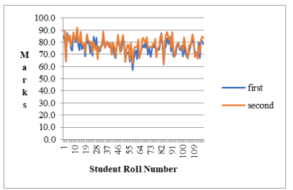
1.3 Overall results of students
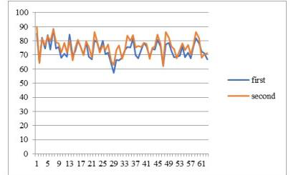
1.4 Result of Male Students
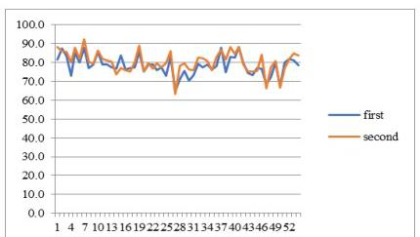
1.5 | Result of Female Students
*Corresponding Author: Rainy 58 | Page

Student Result Management System
1 | Define the requirements: The first step is to define the system requirements. This requires identifying
stakeholders such as teachers, students, administrators and parents and understanding their needs.
2 System Design: Design the system architecture and user interface according to the requirements. The design must be user-friendly, intuitive and efficient.
3 System Development: Once the design is complete, develop the system using programming languages and tools. Make sure the system is scalable and can handle large amounts of data.
4 Test the system: Test the system thoroughly to make sure it meets your requirements and works properly. This includes testing for bugs, security holes and performance issues.
5 System Deployment: Once the system has been tested and validated, deploy it to a production environment. Ensure that the necessary hardware, software and network resources are in place.
6 Train users: Train users, including teachers, students, and administrators, to use the system effectively. 7 System Maintenance: Maintain the system regularly to ensure it is working properly. This includes software updates, bug and security fixes.
8 System Improvement: Continually improve the system based on user feedback and changing requirements. This could mean adding new features, optimizing performance or improving the user interface.
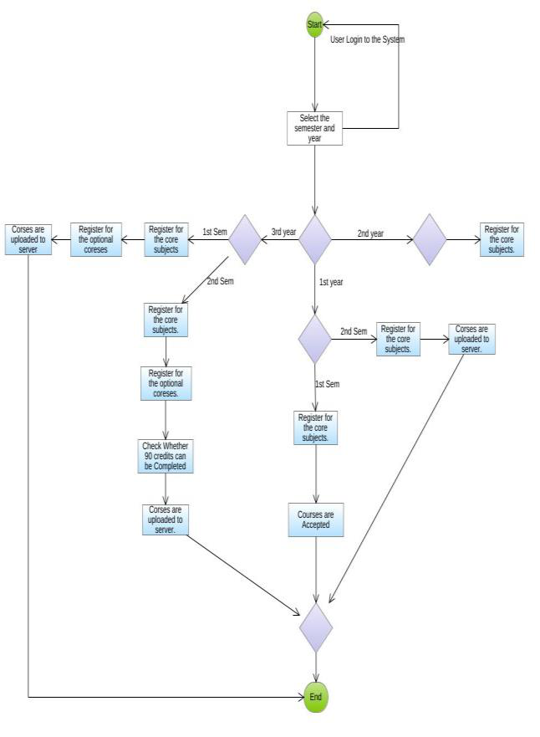
1.6 Flowchart of the management system
V.PROPOSEDMETHOD
The online student management system is the process of managing the student documents of the educational institution organization This is done through an online method that was traditionally produced with papers and manual ledgers It preserves the resources of students and administrators. This system provides a simple user interface for maintenance from students' data [3]. This includes measures such as recording the researcher's data, appointment department according to the chosen course and accounting. Because network system, availability Information is global, which means access and information exchange is global. This information is saved safely in an archive that makes it easy to retrieve and the data can be edited if necessary. This is a software designed for the daily management of student documents in educational institutions. It helps to get information about students of a particular class with just a few clicks. This system also helps creating a student status report such as total amount, requested transaction, payment information, access to information and so on. Click the mouse and the system will generate a student report that reduces the need for manual work which is prone to error and time consuming. This application is designed for automatic processing of student data management. It even heals speed of solving tasks. Student information is stored by batch, department and section. Students and staff have a unique username and password available for email through the OTP concept Microservices architecture is used for application development and deployment. The microservices architecture is implemented using Spring-boot, which is a spring application opinion instance and also a rapid application
*Corresponding Author: Rainy 59 | Page

Student Result Management System
development platform. The proposed methodology has 5 stages, which are requirements gathering, planning, development and implementation, testing and maintenance.
1. Requirements for assembly
Before starting projects, requirements must be gathered and their feasibility checked. The project can continue if the requirements are feasible. In this phase, the stakeholders collect all the requirements necessary for the development and implementation of the project and communicate them to the designer and designer. In this project, the final product of which will be a web application, the requirements are divided into six categories such as Student Management Service, Course Management Service, Attendance Service, Administrative Management Management, Document management service, employee management service.
2. Student Administrative Service
In this service, a student can check his attendance, progress report, result, send request for required documents, view notifications, view schedule, view and submit assignments. Students can give feedback on the teachers' performance in the class.
3. Course management service
In this service, the administrator can add, edit and delete courses. The administrator can also add, update and delete certain course topics. The teacher, guardian and students can only see the courses added by the administrator.
4. Participant management service
In this service, a system administrator can report student attendance information, update and delete student attendance according to the course and class they belong to. The teacher, guard and students can only see the attendance.
5. Administrative management service
In this service, the administrator has access to all resources. The system administrator can send notifications via email, SMS and push messages. The system administrator can also add, update and delete the data of students, guardians and staff.
6. Document management service
The system administrator can add documents to this service, such as student report cards, ID cards, curriculum, payment receipts, certificates and many other documents that are useful for the smooth operation of educational and financial activities of the educational institution.
7. Employee management service
In this service, the employee (teacher) can see the data of the students he supervises. The teacher can report on the students' activities and evaluate the students' performances. The teacher can download the assignments and check the assignments.
VI.CONCLUSION
In short, it can be stated that the student results management system is a key tool for educational institutions to manage student data effectively and efficiently. With functions such as student registration, assessment and evaluation, attendance tracking, reporting and analysis, communication and integration with other systems, a student performance management system can help simplify administrative processes, improve communication between teachers, students and parents, and provide valuable information about student performance data. Implementing a student performance management system can increase productivity, improve learning outcomes and improve engagement between teachers, students and parents. Overall, a student performance management system is an invaluable tool for educational institutions that want to optimize their operations and improve student learning outcomes.
The results obtained from experiments and testing ensure that the proposed method is effective and usable. Compared with existing management methods of educational institutions, this centralized software production project facilitates work management and administration, and provides users with detailed information on an interesting topic with one click. An educational institution can be offered easy-to-use software focused on the user interface, where all services related to the educational institution can communicate with each other and share information. Since it is AWS Cloud Hosted ReST API, the user can access the resources from remote locations. Because the application is developed with a microservices architecture and agile methodology, services can be added in the future without changing the existing code.
*Corresponding Author: Rainy 60 | Page

Student Result Management System
REFERENCES
[1] Gagn’e, R. (1985). The conditions of learning and theory of instruction. (4th Ed.) New York: Holt, Rinehart & Winston. [2] Smith, J. & Naylor, R. (2001). Determinants of degree performance in U.K. universities: a statistical analysis of the 1993 student cohort. Oxford Bulletin of Economics and Statistics, 63, 1, 29-60.
[3] Yang, B., & Lu, D. R. (2001). Predicting academic performance in management education: An empirical investigation of MBA success.Journal of Education for Business, 77, 15-21.
[4] Ofori, R. & Charlton, J. P. (2002). Issues and innovations in nursing education: A path model of factors influencing the academic performance of nursing students. Journal of Advanced Nursing, 38, 507-515.
[5] McKenzie, K., Gow, K. & Schweitzer, R. (2004). Exploring first-year academic achievement through structural equation modelling. Higher Education Research & Development, 23, 1, 95-112.
[6] Carroll, C. A., Garavalia, L. S. (2004). Factors contributing to the achievement of pharmacy students: Use of the goal-efficacy framework. American Journal of Pharmaceutical Education, 68, 4, 88.
[7] Zeegers, P. (2004). Student learning in higher education: a path analysis of academic achievement in science. Higher Education research & Development, 23, 1, 35-56.
[8] Naeimeh Delavari, “Application of Enhanced Analysis Model for Data Mining Processes in Higher Educational System “, 2005 IEEE July 7 Juan Dolio, Dominican Republic ITHET 6th Annual International Conference.
[9] Fahim A. M., Salem A. M., Torkey F. A. and Ramadan M. A., “An efficient enhanced k-means clustering algorithm,” Journal of Zhejiang University Science A., pp. 1626–1633, 2006.
[10] Sujit Sansgiry, M. Bhosle, and K. Sail, “Factors that affect academic performance among pharmacy students,” American Journal of Pharmaceutical Education, 2006.
[11] Robbins, S. B., Allen, J., Casillas, A., Peterson, C. H. & Le, H. (2006). Unravelling the differential effects of motivation and skills, social and self-management measures from traditional predictors of college outcomes. Journal of Educational Psychology, 98, 3. [12] Bouras, “A Survey of Clustering Algorithms for Big Data: Taxonomy & Empirical Analysis,” IEEE transactions on emerging topics in, (2014).
[13] S.ARORA, I.CHANA, “A survey of clustering techniques for Big Data analysis,” in Confluence The Next Generation Information Technology Summit (Confluence), 5th International Conference-. IEEE, p. 59-65, (2014).
[14] Pooja Thakar, Anil Mehta , “Performance analysis and Prediction in Educational Data Mining”, International Journal of Computer Applications (IJCA) , Volume 110, Issue 5, January 2015.
[15] Niranjan Lal, Shamimul Qamar , Monika Kalra, “K- Mean Clustering Algorithm Approach for Data Mining of Heterogeneous Data” Information and Communication Technology for Sustainable Development{ICT4SD), LNNS, Springer Proceeding , Volume 10, pp.61-70 2017.
[16] Niranjan Lal, Navneet Kaur, "Clustering of Social Networking Data using SparkR in Big Data" Springer Nature Singapore Pte Ltd. 2018, Communications in Computer and Information Science (CCIS), Volume 906, pp. 217–226, Nov, 2018.
[17] Kaberia, F. (2020). Enhancing quality and relevance in university education (Kenya). Paper presented in the fourth exhibition by Kenyan Universities, Nairobi: Kenya.
[18] | Tam, M. (2020). Measuring the effect of higher education on university students. Quality Assurance in Education, 10, 4, 223- 228
*Corresponding Author: Rainy 61 | Page

